**Zeppenlin Installation Guide**

* Download Zeppenlin from the official website (binary all version)
* Make sure jdk (version 1.7.0 or later) is installed in the system
* Make sure Spark is installed in the system
* Edit .bashrc file:

In command terminal: $ vi .bashrc

In bashrc file, give the correct jdk and Spark directory to JAVA_HOME and SPARK_HOME.

E.g. 

Save and back to terminal by: esc -> :wq

* Use the updated .bashrc file:

In command terminal: $ source .bashrc

* Configure the Zeppelin.

Go to Zeppenlin directory, in the ‘conf’ folder, find file ‘zeppelin-env.sh.template’ and ‘zeppelin-site.xml.template’, make a copy as ‘zeppelin-env.sh’ and ‘zeppelin-site.xml’

* Edit ‘zeppelin-env.sh’, give the correct jdk and Spark directory to JAVA_HOME and SPARK_HOME.

E.g.

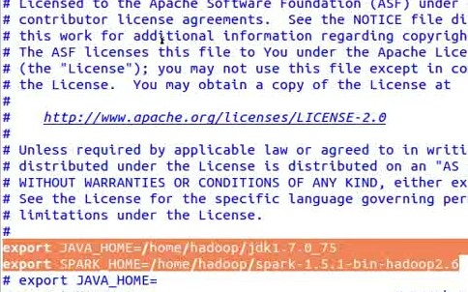

Save and close the file.

* Edit ‘zeppelin-site.xml’, change the port to make sure it does not conflict with your other port settings

E.g.

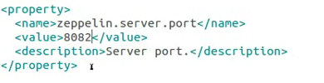

Save and close the file.

* Start Zeppelin.

In command terminal, ‘cd’ to the Zeppelin directory.

Start Zeppelin by: $ bin/zeppelin-daemon.sh start

E.g.



Check Zeppelin status by: $ jps

E.g.

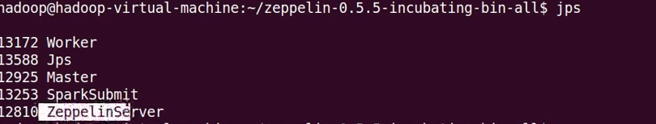

Zeppelin is started successfully

* Start Spark.

In command terminal, ‘cd’ to the Spark directory.

Start Spark by: $ sudo sbin/start-all.sh

E.g.



Check Spark status by: $ jps

* Use Zeppelin in Browser.

Open firefox, enter ‘localhost:8082’ as address.

Zeppelin is then open and ready:

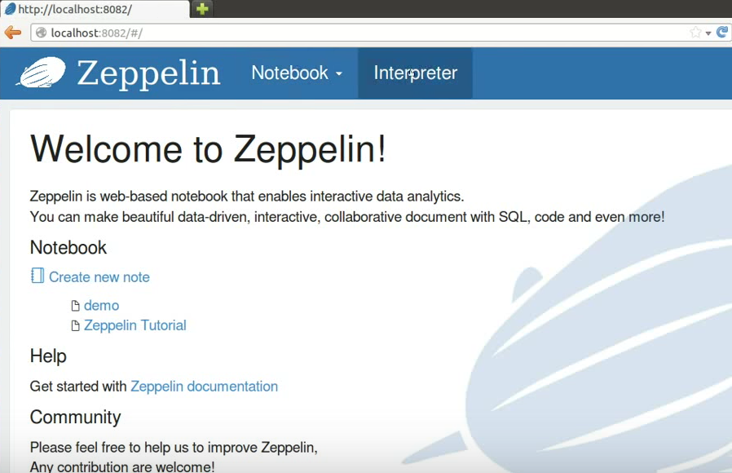

* In ‘Interpreter’ tab, you can configure your intepreters (Hive, Spark, etc.)
* In ‘Notebook’ tab, you can create a new note for your analysis.

E.g.

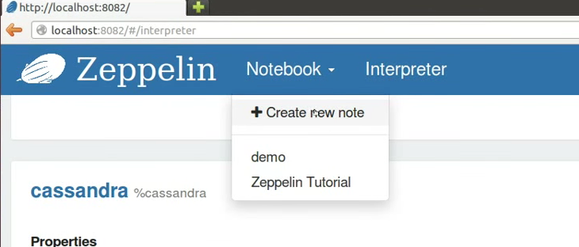

Print ‘hello world’ as a test.

